Final Project for E-Business

“Team INCOGNITO”
Calhil T. Baluyut
Nelson O. Guinmapang Jr.
Jairus V. Lansang
Michael M. Magat

Submitted to:
Mr. Paul Pajo

Content Provider
Relationship: Content providers tend not to own the relationship with the customer. They provide information to complementors, who resell their services to customers, for subscriptions, as in the Wall Street Journal Interactive. Please note that they may sometimes share the customer relationship with the customer if they brand their content, as in the case of AOL
Data: Rarely do content providers have direct access to customer data, but a strategic partnership could realize this potentiality
Transactions: Customers perceive that they are dealing with CNN Interactive. Even if the content is branded, customers know which Web site they are working with.

Direct to Customer
Relationship: Direct-to-consumer models own the relationship as they are the firm of record for all services and good dispensed to the customer.
Data: This model also owns the behavioural data related to the customer purchases and after sales interactions.
Transactions: Customers perceive that they are dealing with Dell or e-Trade. Even if the hosting of the transaction is outsourced, the URl of note is threat of the firm. This is a very powerful model for e-Commerce, with respect to resources.

Full Service Provider
Relationship: Full-Service providers own the primary relationship with the customer, although nothing prohibits the customer from interacting directly with a supplier or a reseller. There are few examples of mature firms in this category, but Prudential's Advisor and Bank One's Wingspan are close. Fidelity would be a likely possibility for initiating this model.
Data: They also own the data, and share with suppliers or resellers only to the extent that there are mutual benefits accruing from the partnerships.
Transaction: Customers perceive that they are dealing with the full-service provider. Even if the content is branded, customers know which Web site they are working with.

INTERMEDIATOR
SALES
CUSTOMER/ MARKET PLACE
Supplier of different products
Products & Information
&
Needed products
Acquire service
information

Intermediary
Relationship: Intermediaries are the primary contact point with the customers, so they own the relationship. Secondarily, they refer customers to suppliers or complementary, who do not own the relationship with the customer.
Data: In fact, intermediaries can learn a great deal about customer comparison shopping behaviour, but they may or may not have access to the customer purchasing behaviour data. That may be retained by the supplier.
Transactions: The supplier conducts the transaction at their site, and the customer is well aware of this since they are linked to another site.

Shared Infrastructure
Relationship: Shared infrastructure models have several advantages, but owning the relationship is not one of them. In fact, from the standpoint of an individual owner firm, it is advantageous that the buying or selling party identifies with themselves rather than with the infrastructure. Were it otherwise, this model would not work.
Data: The owners of the shared infrastructure own data relating to their own activities. Non-owners may or may not be given access to this data.
Transactions: Owners and non-owners own the transaction since the buyer or seller, as the case may be, is eventually revealed. A traveller eventually knows that it is United Airlines that the ticket is being purchased from, for instance.

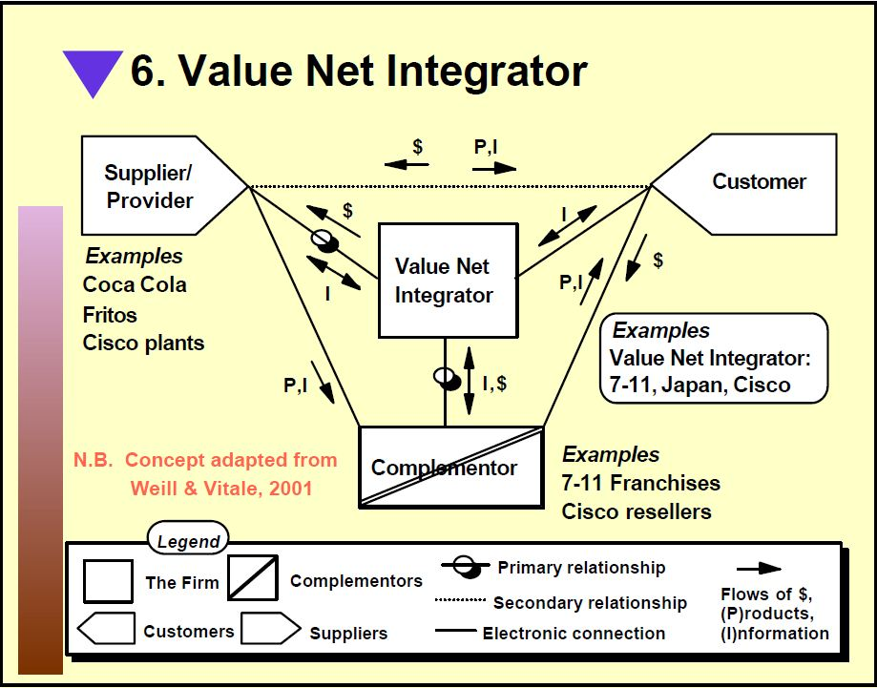
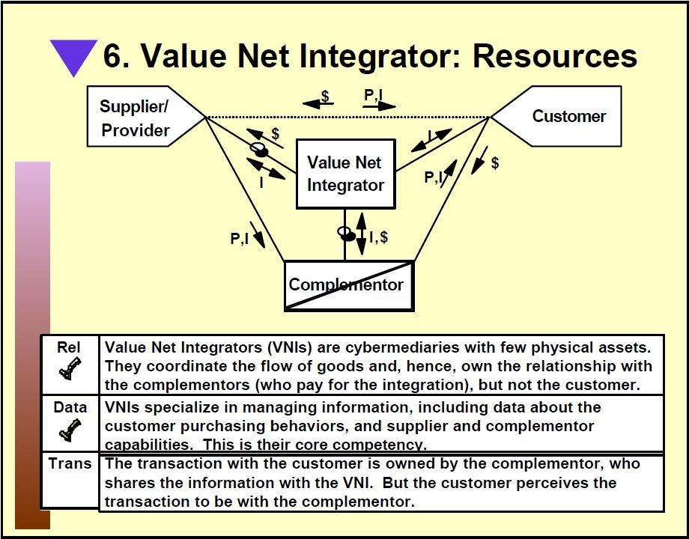
since they are hyperlinked to another site

Virtual Community
Relationship: Virtual communities are most often free services that aggregate information for customers, but they may also serve as an appendage for a business, as in the case Yahoo Groups.
The primary relationship in the model is between customers and the virtual community.
Data: Data about customer interests resides with the virtual community. This could be a source of independent revenue for the firm.
Transactions: There are no transactions to speak of with this model. Organizations use virtual communities as value-added differentiators. They receive money indirectly, through their other sales channels, but not through this firm.

Company 2
Company 1
SALES
CUSTOMERS
Company 4
Company 3
Whole of enterprise
Company 8
Company 7
Company 6
Company 5
information
Products & Information
&

Whole of Enterprise
Relationship: Single point of contact (called "Whole of Enterprise" in Weill & Vitale) shares some of the characteristics of the direct-to-consumer model. It owns the relationship, since that is, in fact, the entire idea behind the model. Customers should not have to seek beyond the single point of contact to have their needs met. There are few mature examples of this model.
Data: Naturally, data is owned by the single point of contact, who attempt to answer questions and direct customers to the products and services they seek.
Transactions: Customers perceive that they are dealing with the single point of contact, and that Web site is their access point.

Source: http://www.cis.gsu.edu/~dstraub/ExecutiveEducation/UNTDec2001/UNT5.pdf

